**SOFTWARE ARCHITECTURE, DEVELOPMENT PROCESS, SOFTWARE TESTING, SECURE CODING PRACTICES AND CI/CD**

**Software Architecture:**

Software architecture is the process of designing a structured solution that meets the technical and operational requirements of a software system. It involves the identification of key components and the interaction between them, along with the selection of appropriate technologies and design patterns.

Some key concepts in software architecture include:

* Architectural styles: A set of principles and design patterns that define the overall structure of the software system. Examples include client-server, n-tier, and microservices architectures.
* Design patterns: Reusable solutions to common design problems that can help developers build robust and maintainable software systems.
* Components and interfaces: The building blocks of a software system, which define how different parts of the system interact with each other.
* Quality attributes: The non-functional requirements of a software system, such as scalability, reliability, and security.

**Development Process:**

The software development process is a set of activities that lead to the creation of a software product. The process typically involves the following stages:

* Requirements gathering: Understanding the business and technical requirements of the software system.
* Design: Creating a high-level design for the software system based on the requirements.
* Implementation: Writing code to implement the design.
* Testing: Verifying that the software system meets the requirements and works as intended.
* Deployment: Making the software system available for use.
* Maintenance: Fixing bugs and making updates to the software system as needed.

There are many different development methodologies that can be used to implement the software development process, including waterfall, agile, and DevOps.

**Software Testing:**

Software testing is the process of evaluating the software system to ensure that it works as intended and meets the requirements. There are many different types of software testing, including:

* Unit testing: Testing individual units of code to ensure that they work as intended.
* Integration testing: Testing the interaction between different units of code to ensure that they work together as intended.
* System testing: Testing the entire software system to ensure that it works as intended.
* Performance testing: Testing the performance of the software system under different conditions.
* Security testing: Testing the security of the software system to ensure that it is resistant to attacks.

**Secure Coding Practices:**

Secure coding practices are techniques and guidelines that can be used to write software that is resistant to attacks. Some key practices include:

* Input validation: Checking user input to ensure that it is valid and does not contain malicious code.
* Error handling: Handling errors gracefully to prevent attackers from exploiting them.
* Password management: Storing passwords securely and using strong encryption algorithms.
* Access control: Limiting access to sensitive data and functions to authorized users only.
* Code review: Having multiple developers review each other's code to catch security vulnerabilities.

**CI/CD:**

Continuous integration/continuous delivery (CI/CD) is a process for automating the building, testing, and deployment of software. The process typically involves the following steps:

* Code changes are made and committed to a version control system.
* The code is automatically built and tested.
* If the tests pass, the code is automatically deployed to a staging environment.
* The code is further tested in the staging environment.
* If the tests pass in the staging environment, the code is automatically deployed to production.

CI/CD can help improve the quality and speed of software development by automating many of the manual processes involved in building, testing, and deploying software.

**Principles of Writing Clean Code**

The principles of clean code are a set of guidelines and best practices for writing code that is easy to read, understand, and maintain. Clean code is important because it reduces the time and effort required to develop, test, and maintain software, and makes it easier for other developers to understand and modify the code in the future.

Some of the key principles of clean code include:

* Readability: Code should be easy to read and understand, even for someone who is not familiar with the project. This means using clear and descriptive names for classes, functions, and variables, as well as organizing the code in a logical and consistent way.
* Simplicity: Code should be simple and straightforward, with a clear and specific purpose. Complex code is difficult to read and maintain, and can lead to errors and bugs.
* Consistency: Code should be consistent in terms of formatting, naming conventions, and style. This makes it easier to read and understand, and reduces the likelihood of errors and bugs.
* Efficiency: Code should be efficient and performant, with a minimal amount of unnecessary code or computations. This helps ensure that the software runs smoothly and does not consume excessive resources.
* Testability: Code should be designed in a way that makes it easy to test, with clear and specific input and output requirements. This helps ensure that the software meets the requirements and works as intended.
* Modularity: Code should be modular and organized into small, independent components that can be easily reused and modified. This makes it easier to maintain and update the code, and reduces the likelihood of errors and bugs.

Overall, writing clean code is important because it makes software development more efficient and effective. Clean code is easier to read and understand, easier to test and maintain, and less likely to contain errors and bugs. By following the principles of clean code, developers can create software that is reliable, efficient, and easy to work with.

Also, Code formatting, naming conventions, functions, and comments are all important aspects of writing clean code. Here's a brief overview of each:

* Code formatting: Code formatting refers to the way that code is laid out and structured. Consistent and readable formatting makes the code easier to read and understand, reducing the likelihood of errors and bugs. Some best practices for code formatting include using consistent indentation, avoiding long lines of code, and using whitespace to improve readability.
* Naming conventions: Naming conventions refer to the way that classes, functions, and variables are named. Clear and descriptive names make the code easier to read and understand, reducing the likelihood of errors and bugs. Some best practices for naming conventions include using descriptive and specific names, avoiding abbreviations and acronyms, and following established conventions.
* Functions: Functions are a key component of clean code, and should be designed in a way that makes them easy to read, understand, and maintain. Some best practices for functions include keeping them small and focused, using descriptive and specific names, and avoiding side effects.
* Comments: Comments are used to explain the purpose and function of code. While comments can be helpful, they should be used sparingly and only when necessary. Some best practices for comments include using clear and concise language, explaining why code is doing something rather than what it is doing, and avoiding unnecessary or redundant comments.

By following these best practices for code formatting, naming conventions, functions, and comments, developers can create code that is easy to read, understand, and maintain, reducing the likelihood of errors and bugs and improving the overall quality of the software.

Writing code that is easy to read and understand is important because code is not just written for machines, but also for other human beings who will need to read and understand it in the future. It is often said that code is read more often than it is written, which means that code readability is an important factor in software development.

Writing code that is easy to read and understand can help in several ways:

* Collaboration: In most software development projects, multiple developers work together to build and maintain the codebase. If the code is not easy to read and understand, it can make collaboration more difficult and increase the likelihood of errors and bugs.
* Maintenance: Code is not a one-time effort; it needs to be maintained over time. If the code is not easy to read and understand, it can be difficult to maintain and update, leading to technical debt and increased development time.
* Debugging: When code contains bugs, developers need to be able to read and understand the code to identify the problem and fix it. If the code is not easy to read and understand, it can be difficult to debug, leading to longer development cycles and more bugs.

While it may take a little longer to write code that is easy to read and understand, the benefits far outweigh the costs. Code that is easy to read and understand can reduce development time, increase collaboration, and improve the overall quality of the software.

Case Study

Case study that demonstrates how to apply the principles of clean code to a real-world project. The case study follows the development of a simple application from start to finish, and shows how the principles outlined in Part 1 can be applied in practice. This section provides examples of code that is not clean, and then shows how it can be refactored into clean, maintainable code.

Let's consider a simple case study to demonstrate how to apply the principles of clean code to a real-world project. Suppose we are building a simple calculator application that can perform basic arithmetic operations like addition, subtraction, multiplication, and division.

In the initial stages of development, the code for the calculator application might look something like this:

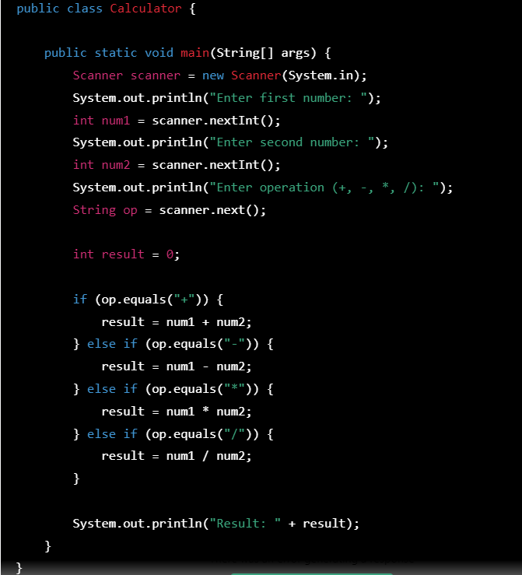

While this code may work as intended, it is not clean and maintainable. Let's consider how we can refactor this code to make it cleaner and easier to maintain.

First, we can improve the code formatting by using consistent indentation, breaking long lines of code, and using whitespace to improve readability. Here's how the code looks after formatting:

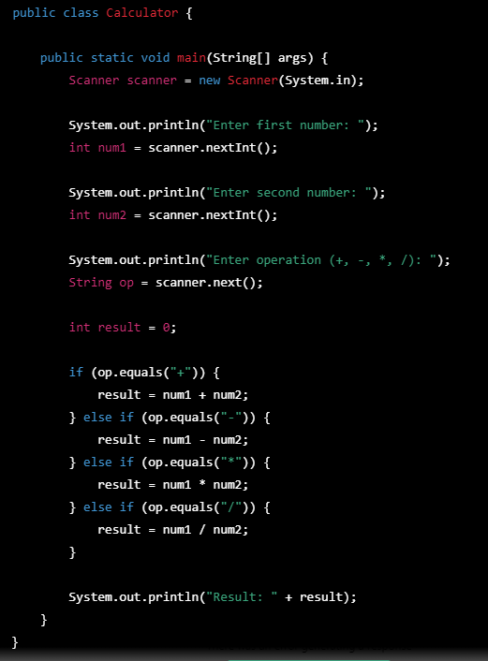

Next, we can improve the naming conventions by using descriptive and specific names for variables and functions. Here's how the code looks after improving naming conventions:

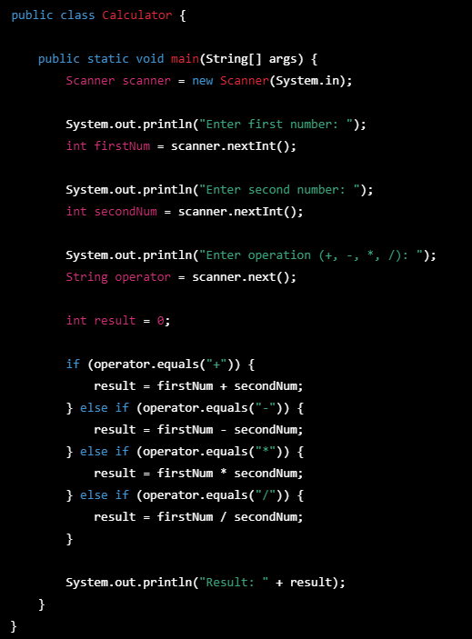

We can further improve the code by breaking down the functionality into smaller, more focused functions. Here's how the code looks after refactoring the logic into separate functions:

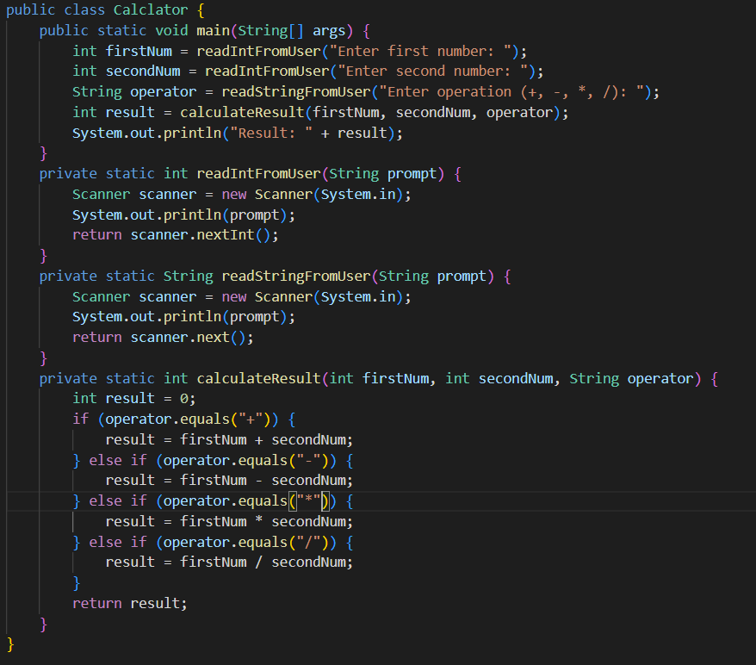

Finally, we can add comments to make the code even more clear and understandable. Here's how the final version of the code looks:

